ওয়েবসাইট
ফ্রন্ট এন্ড ডেভেলপমেন্ট
কোনটির কাজ কি তা বোঝার খুব সহজ উপায় আছে
===================================================
Responsive
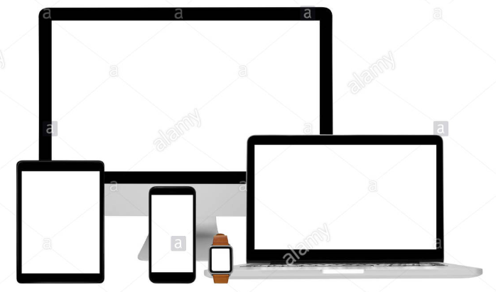

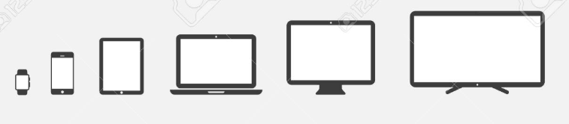



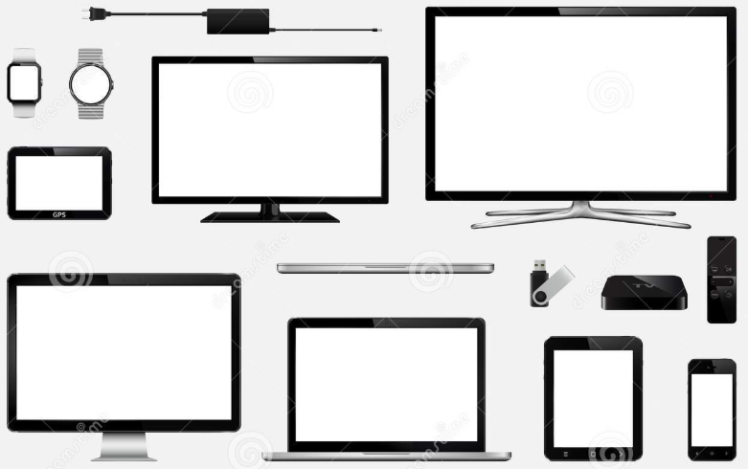



Measurement Window Size
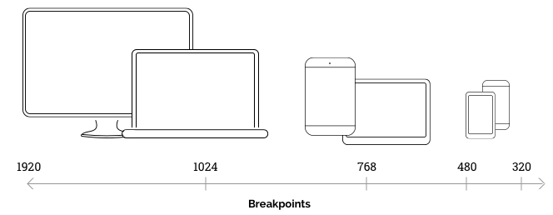
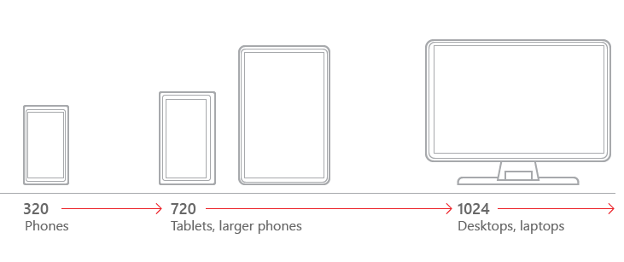
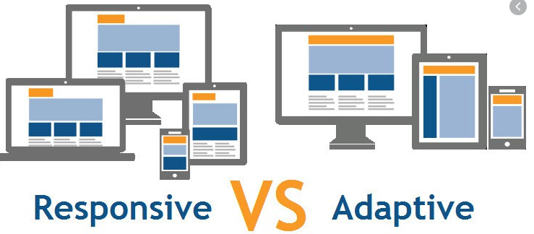

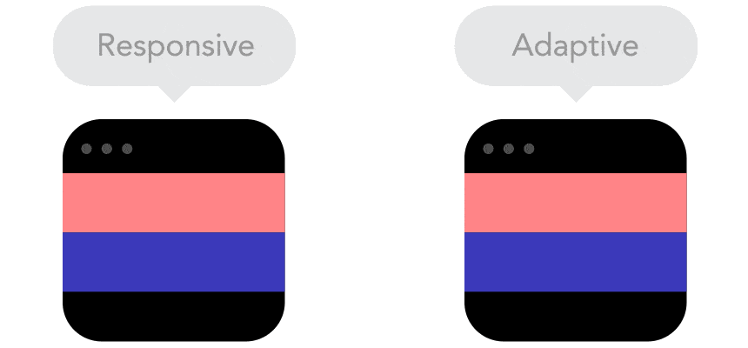
Gif Picture

# What is Retina Display?
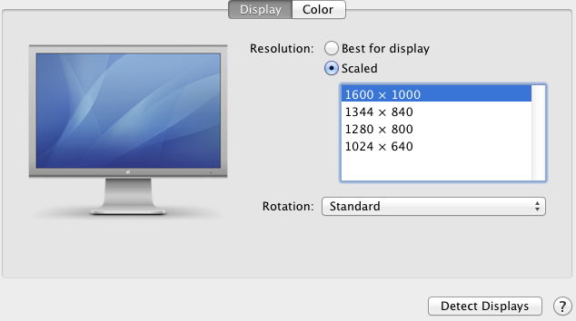

MAC
# Apple's new iMac has a '5K' retina display with 14.7M pixels
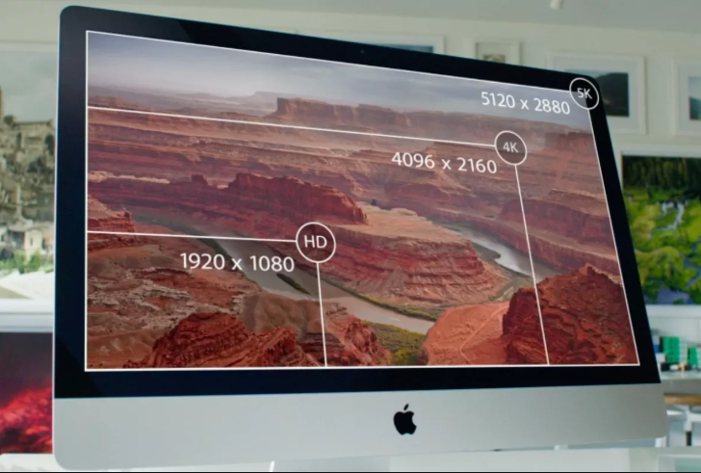

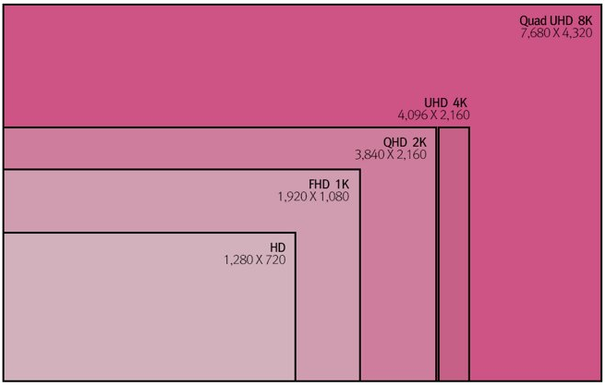

#Key Terms
- Aspect ratio
Golden ratio
ratina display
HD
FHD(1K)
QHD(2k)
UHD(4k)
Quad UHD(8k)
Screen Resolution
#Sky, Apple Imac Retina 5k
#How to Run Your Retina Display at its Native Resolution

